C Value = 0.1

Gamma = 0.0001

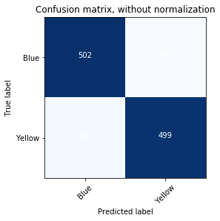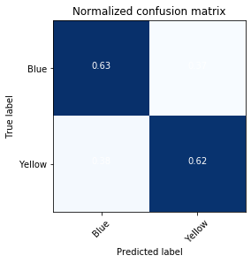

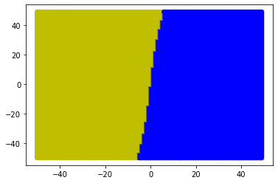

C Value = 0.1

Gamma = 0.001

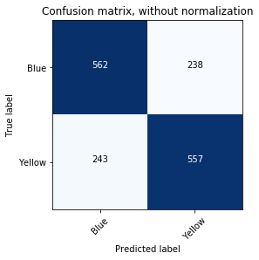 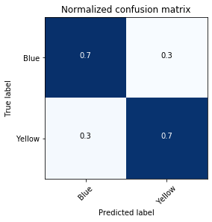

sensitivity = 0.69625

specificity = 0.7025

precision = 0.70062893081761

recall = 0.69625

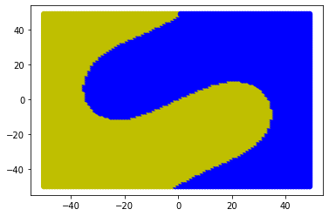

C Value = 0.1

Gamma = 0.01

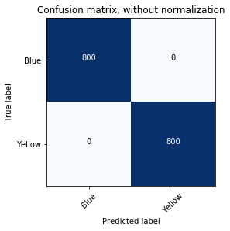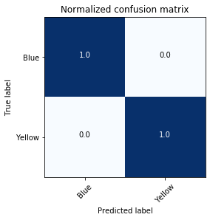

sensitivity = 1.0

specificity = 1.0

precision = 1.0

recall = 1.0

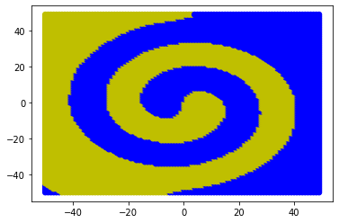

C Value = 0.1

Gamma = 0.1

 

sensitivity = 1.0

specificity = 1.0

precision = 1.0

recall = 1.0

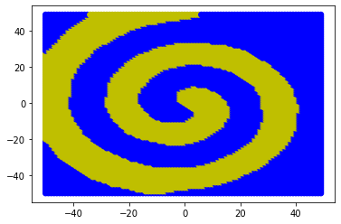

C Value = 0.1

Gamma = 1

 

sensitivity = 1.0

specificity = 1.0

precision = 1.0

recall = 1.0

